Lakshmi Durga Puppala

Information Technology Field Experience – EX30

Cumberland University

July 27th, 2025

**Progress Report for Milestone 3**

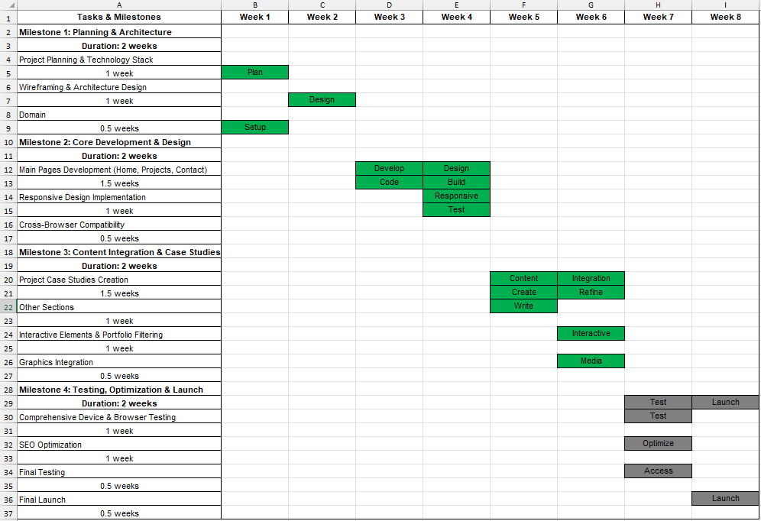**Below is the updated Gantt Chart after Milestone 3:**

|  |  |
| --- | --- |
| Completed - Finished Tasks |  |
| In Progress - Currently working |  |
| Not Started - Pending Tasks |  |

**A. What was our Milestone and subtasks?**

Our third milestone was "Content Integration & Case Studies", which focused on bringing the website to life with actual content. The main subtasks for this phase were:

* **Project Case Studies Creation:** Writing detailed descriptions and gathering materials for the projects I want to showcase in my portfolio.
* **Writing Content for Other Sections:** Filling out the "About Me", "Services" and other pages with clear and relevant information.
* **Implementing Interactive Elements:** Adding features like filtering to the portfolio so visitors can easily sort through projects.
* **Graphics Integration:** Selecting, optimizing and placing images and other media to visually support the content.

**B. Were we successful or not? Why or why not?**

Yes, this milestone was a success. The website now feels like a complete portfolio rather than just a template. Having a solid structure from Milestone 2 allowed me to focus entirely on the content. I was able to write all the necessary text and integrate the visuals smoothly. The portfolio is now functional and populated with my case studies, making the website ready for final testing.

**C. What did we learn from the past 2 weeks?**

Over the last two weeks, I learned how important good storytelling is when creating project case studies. It’s not just about showing the final product but also explaining the process and challenges. On the technical side, I learned how to implement JavaScript for portfolio filtering, which was a great hands-on experience. I also gained a better understanding of how to optimize images for the web to ensure the site loads quickly without losing visual quality.

**D. What is our next Milestone, subtasks and deadline?**

Our next and final milestone is "Testing, Optimization & Launch." This is where we ensure everything is working perfectly before the website goes live. The subtasks include:

* **Comprehensive Device & Browser Testing:** Making sure the site works correctly on different devices (desktops, tablets, phones) and browsers (Chrome, Firefox, Safari).
* **SEO Optimization:** Applying basic Search Engine Optimization techniques to help people find the website through search engines.
* **Final Testing:** Doing one last check of all links, forms and content to catch any mistakes.
* **Final Launch:** Deploying the website to the live server.

The deadline for this final milestone is in two weeks.

**E. What do we need to do in our own time to make sure that we are successful?**

To make sure the final milestone is successful, I need to be very thorough in my testing. I will create a checklist of all the things to test so I don't miss anything. I also plan to spend some time learning the fundamentals of SEO to make sure I do a good job with the optimization. Finally, I will ask a friend or family member to look at the website before the launch to get a fresh perspective and catch any errors I might have overlooked.